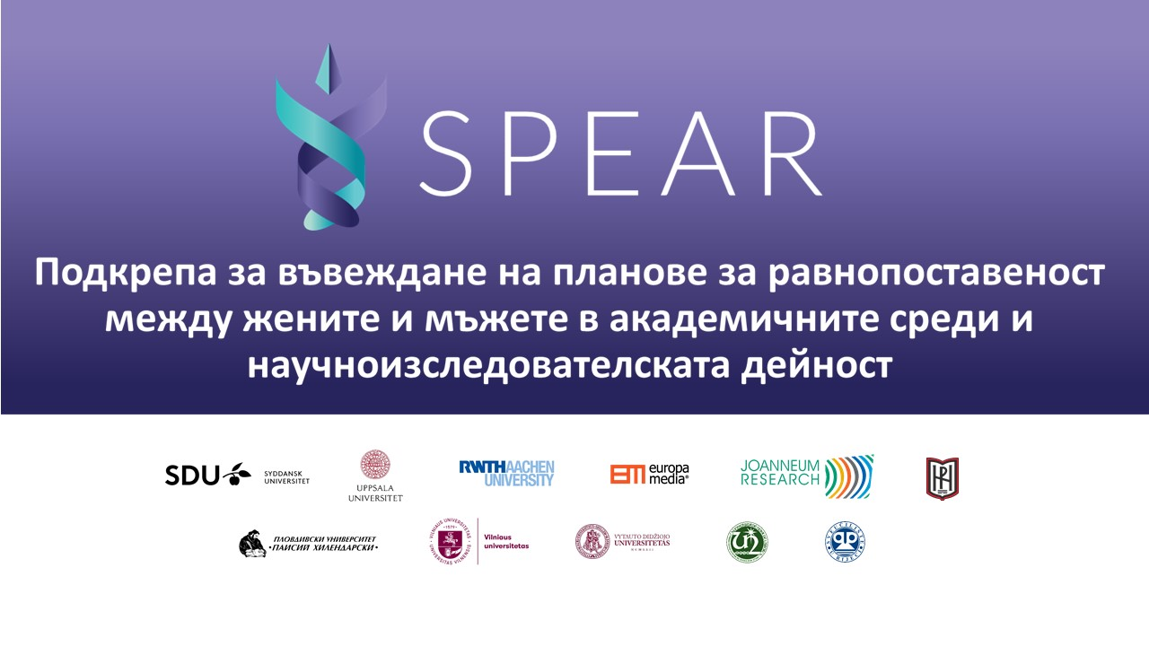
SPEAR
Supporting and Implementing Plans for Gender Equality in Academia and Research

Equality between men and women is one of the characteristics of a developed modern society and democracy. It is also one of the main goals of the EU. Various projects and financial mechanisms are envisaged and designed for its implementation.
The SPEAR project /Supporting and Implementing Plans for Gender Equality in Academia and Research/ is committed to researching absolute gender equality in these areas. Its main goal is to develop and implement a plan for gender equality in them.
As a modern and rapidly developing Bulgarian state university, SWU "Neofit Rilski" is ambitious to assist in the development of this social process. The opportunities for equality between men and women among the teaching and administrative staff, among students and doctoral students, are factors for improving the authority of SWU "Neofit Rilski" as a university fully involved in modern public life.
The project is funded by the EU's Horizon 2020 program and is implemented through cooperation between partner organizations from 9 European countries. The project includes universities and non-governmental organizations from Denmark, Germany, Hungary, Sweden, Austria, Croatia, Portugal, Lithuania, and Bulgaria /SWU "Neofit Rilski" and PU "Paisii Hilendarski"/. South-West University "Neofit Rilski" is part of this consortium, coordinated by the University of Southern Denmark (SDU).

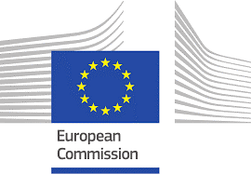

Main goals of the project:

- Compliance of the practice in the University with the good European practices concerning gender equality;
- Promoting opportunities for equality without setting forced requirements and targets;
- Removing barriers and improving professional prospects for women in academia and education;
- Developing researches on gender equality;
- Providing institutional support for gender equality;
- Improving gender balance in the management (structures of the University;
- Raising awareness of existing gender equality issues;
- Promoting a reasonable change in the value system.

The relationships between the participants in the project provide an opportunity for mutual support and exchange of experience.

Participants in the project consortium:

1. SYDDANSK UNIVERSITET (SDU), ODENSE, DENMARK
2. UPPSALA UNIVERSITET (UU), UPPSALA, SWEDEN
3. RHEINISCH-WESTFAELISCHE TECHNISCHE HOCHSCHULE (RWTH), AACHEN, GERMANY
4. EUROPA MEDIA SZOLGALTATO NON PROFITKOZHASZNU KFT (EM), BUDAPEST, HUNGARY
5. JOANNEUM RESEARCH FORSCHUNGSGESELLSCHAFT MBH (JR), GRAZ, AUSTRIA
6. SOUTH-WEST UNIVERSITY “NEOFIT RILSKI” (SWU), BLAGOEVGRAD, BULGARIA
7. PLOVDIVSKI UNIVERSITET “PAISIY HILENDARSKI” (PU), PLOVDIV, BULGARIA
8. VILNIAUS UNIVERSITETAS (VU), VILNIUS, LITHUANIA
9. VYTAUTO DIDZIOJO UNIVERSITETAS (VMU), KAUNAS, LITHUANIA
10. UNIVERSIDADE NOVA DE LISBOA (UNL), LISBOA, PORTUGAL
11. SVEUCILISTE U RIJECI (UNIRI), RIJEKA, CROATIA

Participants in the project team from SWU "Neofit Rilski":

Assoc. Prof. DSc. Petya Pachkova
Prof. Dr. Boris Manov
Prof. DSc. Valentina Milenkova
Assoc. Prof. Dr. Gergana Popova
Assist. Prof. Asen Balabanov
Miglena Lungolova, PhD Student

